create table Customers(

Customer_id int primary key ,

First_name varchar(10),

Last_name varchar(10),

Email varchar(20));

Create table biometric_orders(

order_id int primary key ,

order_date date ,

order_status varchar(10),

Customer_id int ,

FOREIGN KEY (Customer_id) REFERENCES Customers(Customer_id));

create table biometric_Products(

products_id int primary key ,

biometric_name varchar(10),

description varchar(10),

unit_price int );

Create table orders_details(

order_id int ,

product_id int ,

quantity int ,

subtotal int ,

foreign key (order_id) references biometric_orders(order_id),

foreign key (product_id) references biome

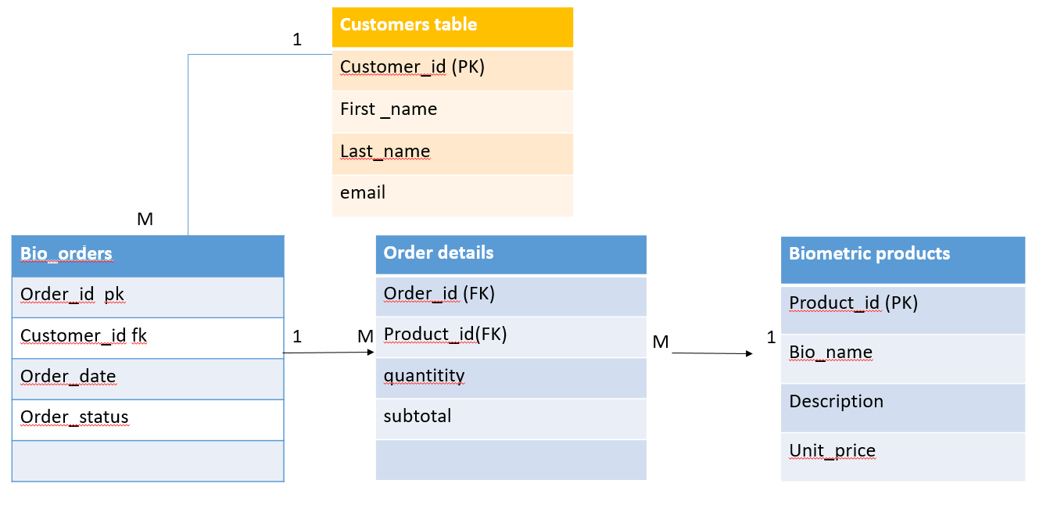

tric_Products(products_id));